Spokane Orchid Society’s 38th
Orchid Show and Plant Sale
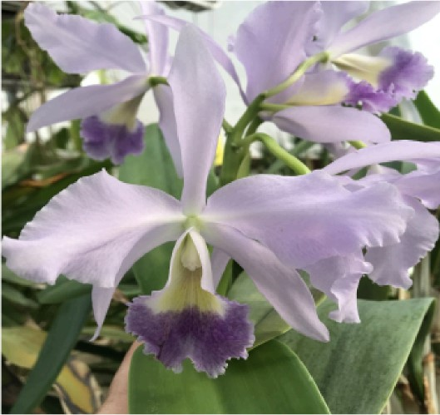
Spokane Community College
Student Lair
1810 N. Greene Street

International & PNW Vendors!
Orchid Culture Classes
Orchid Repotting
March 14th: 10am-5pm
March 15th: - 10am-3pm
$5.00 /person
Free Admission for Veterans, First Responders, and Students (with ID)

ORCHIDS * CARNIVOROUS PLANTS * TILLANDSIAS  CERAMICS * CACTI * HOUSE PLANTS * AROIDS  ANTHURIUMS * OTHER EXOTIC PLANTS  CHILDREN'S COLORING AREA | 

